# Teams Post Templates

As we are using the same MS Teams channel for the various project updates, we want to mark each post based on its target audience. This would help the targeted members to identify whether the post requires their attention or not.

To use the banner, simply right click the relevant banner below, click copy & then paste it at the top of your Teams post.

**Project Team [everyone]**

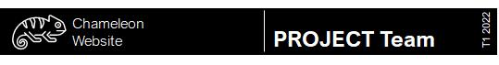

**Design Team**



**Web & App Development Team**



**Data Science Team**



**Icon Templates**



Primary Font

Arial Nova

Alternative Windows Fonts

Arial Black (kerning or character spacing tight)

Arial